**PROJECT REPORT**

**ON**

**Precaution from Corona**

**Virus**

# Using HTML, CSS,

# and JavaScript

## Bachelor of Computer Application

**[BCA-1st]**

**Submitted To:-**

## Shree H.N.Shukla College



**Affiliated To:-**

**Saurashtra University,Rajkot**

**Guided :- prepared :-**

## Mayur Sir Arjun K. Parmar

|  |  |
| --- | --- |
| **SR. NO** | **INDEX** |
| **1** | PREFACE |
| **2** | ACKNOWLEDGEMENT |
| **3** | STUDENT PROFILE |
| **4** | INTRODUCTION OF YOUR PROJECT |
| **5** | PROJECT PROFILE |
| **6** | SYSTEM DESIGN |
| **7** | PROJECT CODING |
| **8** | CONCLUSION |
| **9** | BIBLIOGRAPHY |

### PREFACE

**My Project is about Precaution from very d dangerous corona virus.**

**Corona is a very dangerous virus which is around all over earth. Corona has climed countless lives. Their for I create useful project for precaution from corona virus.**

**From my website you will learn how to stay protected from this horrible thing.**

### 

### ACKNOWLEDGEMENT

**I would thanks to my class teacher Mayur sir who gives me way to how I create this project and also thanks to mital mam who helps me in some little things like editing and basic codes.**

**Many people have contributed to make this project a reality, and I would like to thank them all. I guess I should start with the our Admin who has encouraged us to do project with our best efforts.**

**I express my sincere gratitude Mayur Sir(Project Guide) for his timely help and guidance at every stage of execution and development of the project. He always encouraged me. Whenever i have any kind of problem, he paid attention to them**.

**My special thanks to our college staff who is very much co-operative & helpful throughout the LAB session. Without their co-operation project would not be successful. They taught me on how project can be better and successful.**

**STUDENT PROFILE**



|  |  |
| --- | --- |
| **NAME :** | **Parmar Arjun Kishorbhai** |
| **ADDRESS :** | **“Saidham”, Hemavant Society, Khamdhrol Road, Junagadh-362001.** |
| **COLLEGE :** | **H.N.Shukla Group Of Colleges** |
| **STREAM :** | **BCA** |
| **CLASS :** | **2C** |
| **MOBILE NUMBER :** | **9328082187** |
| **WHATSAPP NUMBER :** | **9328082187** |
| **EMAIL ADDRESS :** | **akp@gmail.com** |
| **BASIC SKILL :** | **HTML, CSS, JavaScript, Java and PHP** |
| **CERTIFICATES, HONORS AND AWARDS IF**  **ANY :** | **--** |
| **SKILL AND PROFESSIONAL SUMMARY :** | **--** |

**INTRODUCTION**

**My Project about Precaution from corona virus.**

**Precaution From Corona Website :-**

**From my website you learn about how we stay protected from this terrible thing.**

**Maintain a safe distance from others, even if they don’t appear to be sick.**

**Wear a mask in public, especially indoors or when physical distancing in not possible.**

**Choose open, well-ventialled spaces over closed ones. Open a window if indoors.**

**Clean your hands often. Use soap and water, or an alcohol-based hand rub.**

**PROJECT PROFILE**

|  |  |
| --- | --- |
| **Project –Title OR Definition :** | **College Management** |
| **Institute:** | **Shree H. N. Shukla College** |
| Front-End: | HTML, CSS and JavaScript |
| Back-End: | --- |
| Project-duration: | 11apr to 18 apr |
| Developed for: | Global Protection |
| Web Browser | Mozila Firefox,  Google Chrome,  Uc Browser |
| Project Guide: | Mayur Sir |
| Developed By: | Arjun **Kishorbhai** Parmar |
| Submitted To: | Saurastra University |

### PROJECT DESIGN

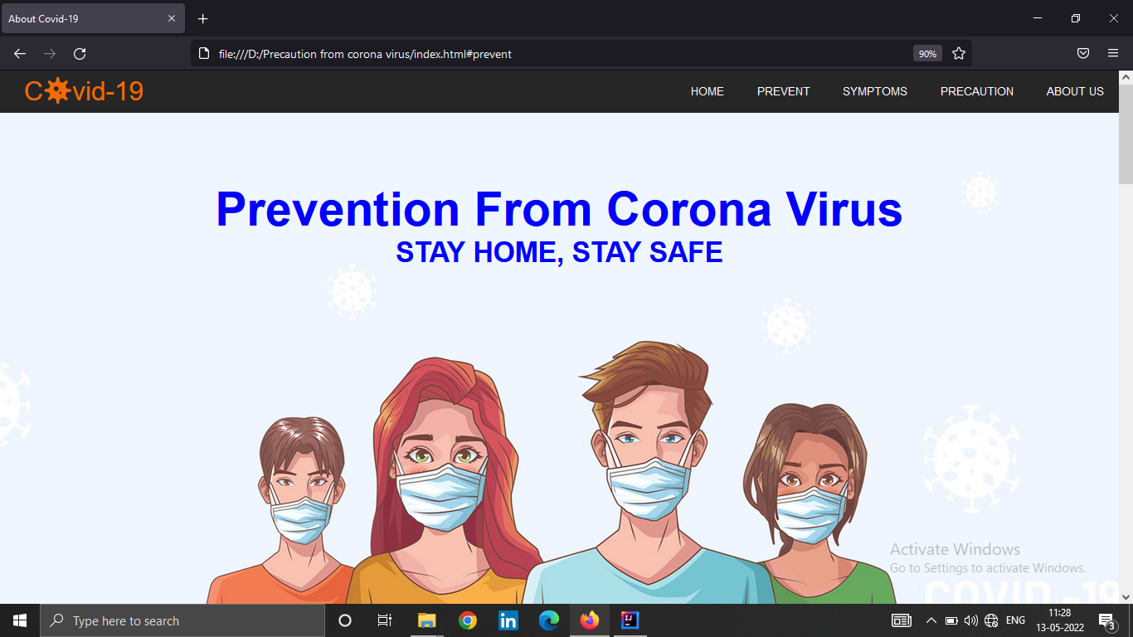

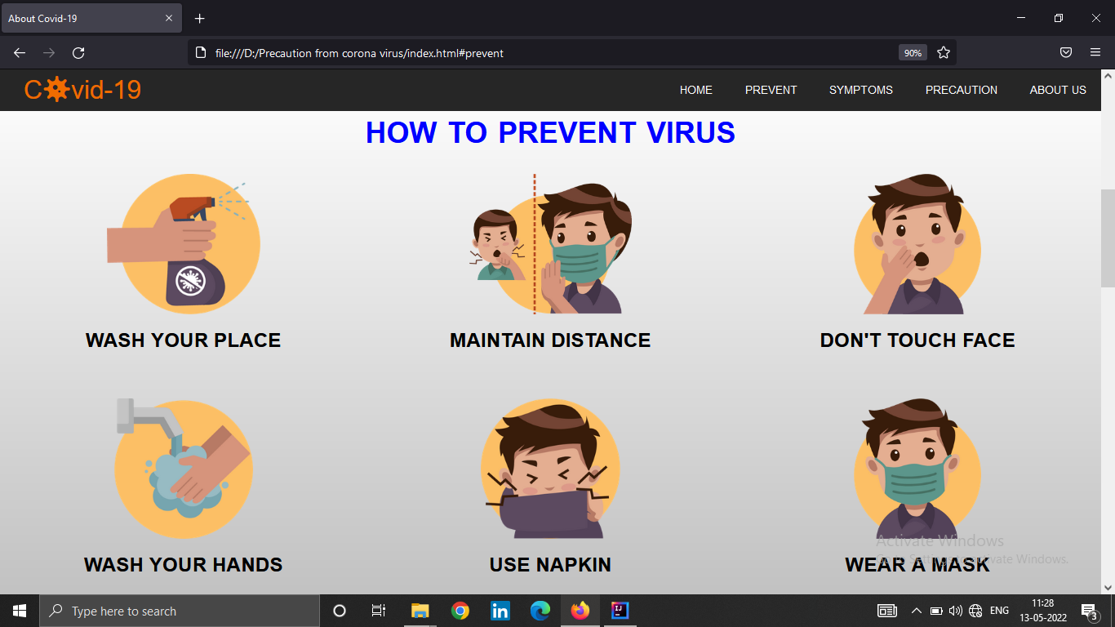

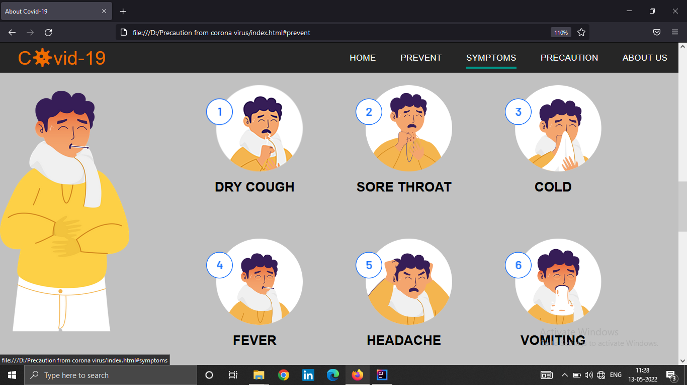

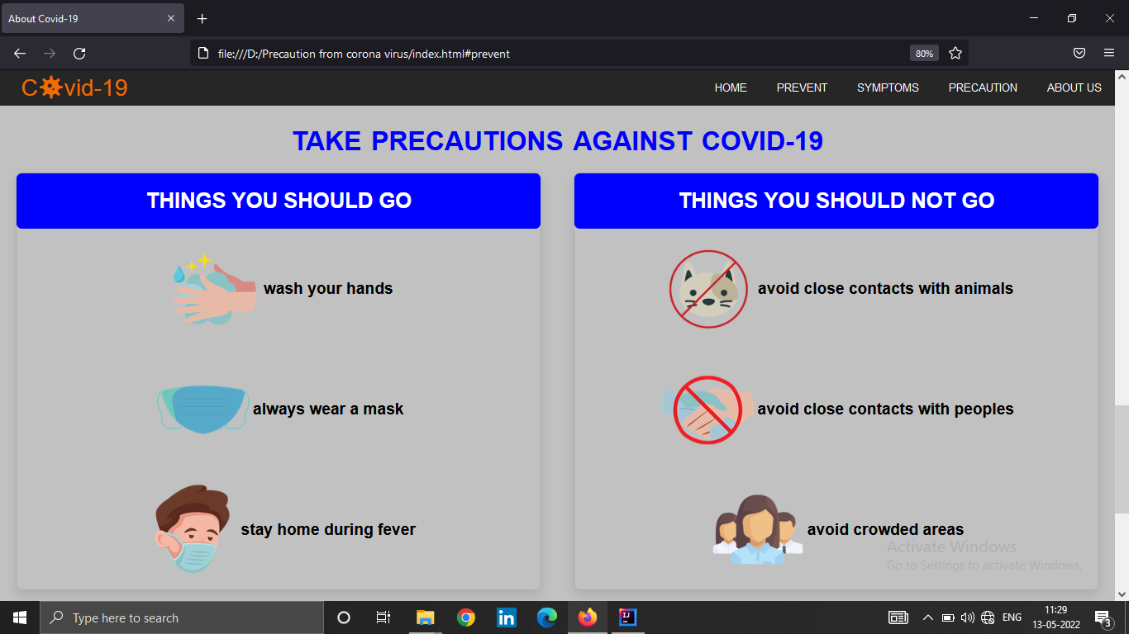

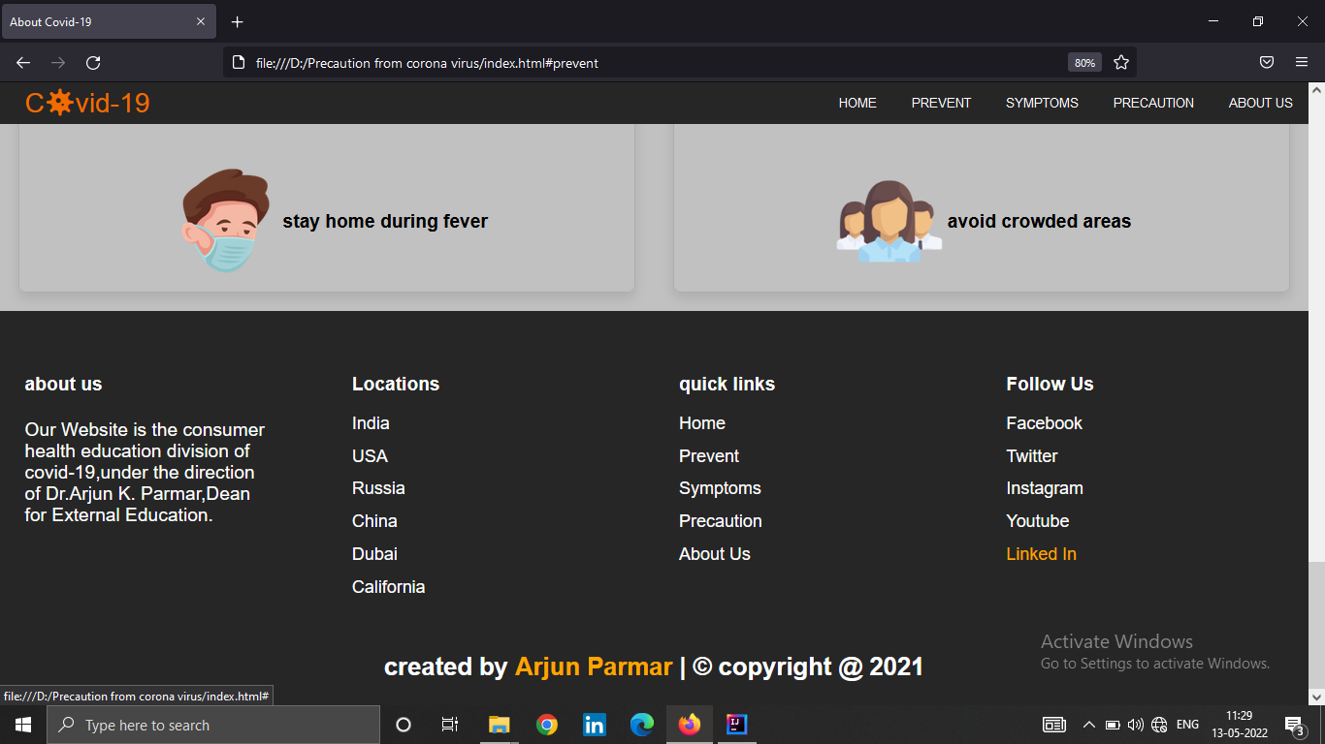

**CONCLUSION**

**Main Perpose Of the project was to protect our earth from this dangerous corona virus. This website help us to how to do this.it is give us way to protection from this horrible thing.**

**It was built with intent of private and secure interaction between user and admin.**

**It has many features such as reliability, efficiency, and easier etc.**

**Through this system things became much easier as they were never before.**

**BIOGRAPHY**

* **WebSites :-**
* [**www.google.com**](http://www.google.com)
* [**www.scrollrevealjs.org**](http://www.scrollrevealjs.org)
* [**www.revealjs.com**](http://www.revealjs.com)
* [**www.fontawesome.com**](http://www.fontawesome.com)
* [**www.cdnjs.com**](http://www.cdnjs.com)
* [**www.googlefonts.com**](http://www.googlefonts.com)
* [**www.pixabay.com**](http://www.pixabay.com)
* [**www.w3schools.com**](http://www.w3schools.com)
* [**www.bootstrap.com**](http://www.bootstrap.com)
* **Search Engines :-**
* [**www.google.com**](http://www.google.com)
* [**www.firefox.com**](http://www.firefox.com)